Decision Tree and EV Analysis
Brendan Johnson
College of Business, Western Governors University
Data-Driven Decision Making - C207
Scott Snair
January 25, 2024

Decision Tree and EV Analysis

Business Scenario Summary
A. Summarize the business scenario by doing the following:
- Describe a business question that could be answered by applying decision tree analysis and is derived from the scenario in “Decision Tree Analysis Resources."
The decision to make operational changes can be analyzed using tools like decision trees and calculating the expected value from potential changes to evaluate opportunity costs. Given market research and known knowledge of the current operations and potential opportunities, decisions can be made to assist in making the best decision.
2. Justify why decision tree analysis is appropriate, and include relevant details from the scenario to support your justification.
Given knowledge of the current operation, market data and research about competitors, market research of expected demand, and price points for different products, decision-makers can make better decisions when utilizing the information logically in a tool like a decision tree.
The use of demand and price can offer the payback for the opportunities. The probabilities can provide a realistic outlook of each situation. Together, these can deliver the expected values of different opportunities and assist in evaluating opportunity costs.

Data for Analysis
B. Identify the relevant data values required for your decision tree analysis, including the following: demand, profits per unit, and probabilities.
The relevant data values for the decision tree analysis are the demand projections, profit per unit, and probabilities of market conditions. Each of the three options has different demand projections, profit per unit, and probabilities for market conditions, all stemming from market research. Given the three options, option one is developing new drugs, option two is modifying existing drugs, and option 3 is to change or do nothing.
The first set of data points is the demand projections. These are dependent on probabilities of market conditions. Option 1's demand for favorable and unfavorable markets are 4341 and 1205; for the second option, 5475 and 1807. The last option is 730 and 241.
The next set of data points, profit per unit, is $.62 per unit for option 1, $.47 per unit for option 2, and $.83 for option 3.
Lastly, the probabilities. The probabilities for option one are 72% and 28%, 72% being favorable with higher demand and 28% being unfavorable with lower demand. The second option, modifying existing drugs, is 64% and 36% for favorable and unfavorable conditions. The last option, changing nothing, implies no decision, carrying probabilities for favorable and unfavorable conditions as 82% and 18%.

Decision Tree Process
C. Report how you analyzed the data using decision tree analysis by completing a decision tree diagram that includes each of the following: state-of-nature nodes, calculated payoffs, each expressed out to two decimal places, expected values, each expressed out to two decimal places
The decision tree diagram assists in deciding what a company should do. Given the market research, the possible decisions to be made, and the probabilities of each decision based on demand, the strategic decision of opportunity costs is presented.
The state-of-nature nodes are possible decision points for the firm to make. These points are determined by market research and shape what decisions are available to management. In this case, the three decisions are creating new drugs, modifying existing drugs, or continuing with current drugs.
Calculated payoffs are formulated by each decision profit per unit multiplied by the expected demand in units multiplied by the probability of the market condition. Each decision has a specific product, demand, and probability payoff. Using these, the expected value can be calculated by taking the favorable and unfavorable payoffs multiplied by the correlating market demand percentage and then added together.
For the first decision, new drugs offer payoffs of $ $2,691.42 and $747.10 for favorable and unfavorable payoffs. The expected value of both decisions is $2147.01.
The payoffs for the second decision to modify existing drugs are $2,573.25 and $849.29 for favorable and unfavorable. The expected value of both decisions is $1952.62.
The final decision, doing nothing, yields payoffs of $605.90 and $200.03 for favorable and unfavorable. The expected value of both decisions is $532.84.

Figure 1
Illustration of Payoff and Expected Value

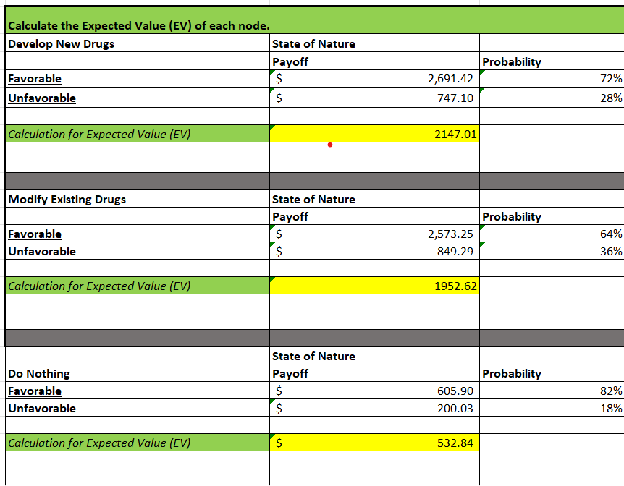
Note: The plot is from an external data analysis discussed in this paper.

Summary of Analysis
D. Summarize the implications of your decision tree analysis by doing the following:
1. Explain each step required to determine the expected value based on payoffs.
Given the analysis, the steps to reach the expected values for each decision are to collect market research data, determine decisions, and calculate payoffs and expected values. Each payoff is determined by multiplying the demand of the good by the profit per unit of the good.
2. List one limitation for each of the following: any one of the data values listed in part B, the decision tree analysis
A limitation of the data included in the analysis is the data from the market research, specifically the probability of the market conditions. The process to arrive at the market condition probabilities from the market research is unclear. Making decisions or using this information to predict demand without knowing how the information was formulated is reckless.
For the decision tree itself, a limitation would be not to make decisions solely based on the results of the decision tree analysis. It only includes three decisions, as there may be more decisions to theorize. Also, more information like costs to transition to a new drug line, either building a new facility or outsourcing manufacturing, would largely change the recommendation for the most desired analysis decision.
Ultimately, data and decision tree analysis is a tool to assist in decision-making, but considering a holistic view of strategic business decisions would include more information than what is provided for the business question.

Recommendation
E. Recommend a course of action that addresses the business question from part A and is based on the results of your decision tree analysis.

Figure 2
Decision Tree Analysis
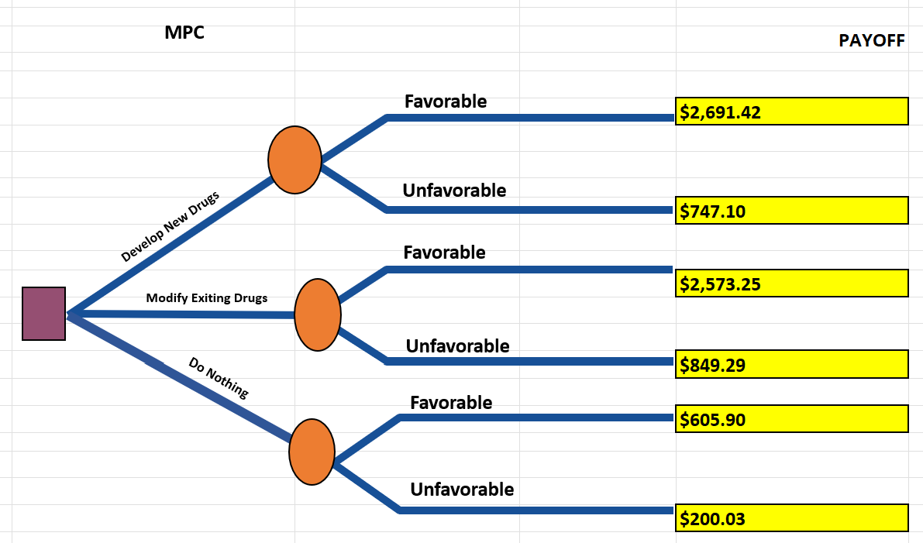
Note: This illustration displays the visualization of the Decision Tree Analysis discussed in this paper.

Based on the information presented, the best decision would be to pursue option one, which is to develop new drugs. This is based on market research, calculating payoffs, and the expected value of each decision.
However, the decision tree analysis should not be used exclusively for business decisions. It should be used to assist in planning based on information collected, such as that associated with market research. Other information and tools should be used for a more well-rounded decision.
References

